St. Stephen Elementary School

STUDENT HANDBOOK
2025 - 2026

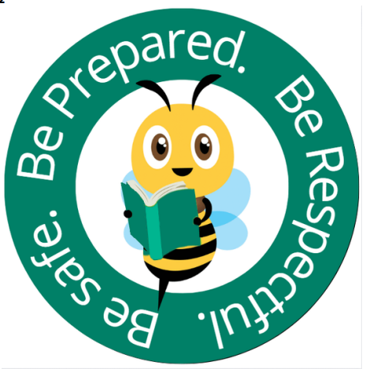

Mrs. Melissa Brown, Principal
Mrs. Courtney Parsons, Vice Principal

16 King’s Court  St. Stephen, N.B.  E3L 3B2 | Telephone: 466-7303  http://sses.nbed.nb.ca  Twitter: @ststephenelem

This Agenda belongs to: __________________________ Grade: ____

ST. STEPHEN ELEMENTARY SCHOOL STAFF
Principal – Mrs. Melissa Brown |  |  | Vice Principal – Mrs. Courtney arsons
Gr. K  Mrs. K. Weeks |  | Gr. K  Mrs. K. Caswell |  |  | Gr. K  Mrs. D. Jones-Comeau
Gr. 1  Mr. T. Worrell |  | Gr. 1  Jill Bartlett |  |  | Gr. 1FI  Mme S. Cooke
Gr. 1FI  Mlle L. Brisley |  | Gr. 2  Mrs. T. Legacy |  |  | Gr. 2FI  Mme J. Agnew
Gr. 2FI  Mlle. A. Weeks |  | Gr. 2  Ms. R. Grant |  |  | Gr. 3  Ms. M. Lott
Gr. 3FI  Mlle A. Bors |  | Gr. 2/3  Mme J. Williams |  |  | Gr. 4  Mrs. T. McCallum
Gr. 4  Mrs. C. Whittier |  | Gr.4FI  Mme. A. Beaubien |  |  | Gr. 4/5FI  Mlle. B. Gullison
Gr. 5  Mrs. K. Perrot |  | Gr. 5  Mrs. K. Noddin |  |  | Gr. 5FI  Mme. R. Chambers
Mrs. J. Dougherty  Music |  | Mr. C. Nelson  Physical Education |  |  | Mrs. K. Grant  Physical Education
Mrs. S. Graves  Art |  | Mrs. M. Richardson  Academic Support |  |  | Ms. K. Malloy  Academic Support
Ms. T. Scott  Resource Teacher |  | Mrs. M. Taylor  Resource Teacher |  |  | Mrs. J. Hall  Resource Teacher
Mrs. J. Bellis  Guidance |  | Community School  Mrs. C. McLanaghan |  |  | Mrs. Stacey Dow  Admin. Assistant
Custodians:
Mr. J. Bartlett | Mr. J. Copeland |  |  | Mr. S. Hovey
Mrs. C. Melanson
Educational Assistants:
Naomi Hooper | Tricia Acheson |  |  | Michelle Anderson
Breanna Curran | Hannah Brown |  |  | Tori Caldwell
Paige Cook | Candice Cleghorn |  |  | Nicole Gullison
Jackie Nordstorm | Jennifer Hartford |  |  | Cherish Helpert
Shannon Landry | Donna McKnight-Farley |  |  | Amanda Prosper
Kelly Richardson | Jelisa Smith |  |  | Jennifer Grover
Kim Hall | Megan Dempsey |  |  | Rosalynn Guest
Janelle Brewer | Olive Stewart |  |  | Rebecca Dow

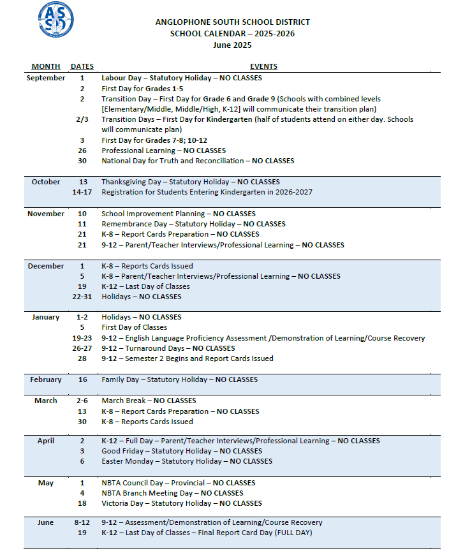

School Supply List 2025-2026

Kindergarten  Labelled Items:  1 spill proof water bottle  1 change of clothing  1 pair of Sneakers (No tying laces- Velcro, elastic laces etc)  Please DO NOT label Items:  20 pencils – HB (sharpened)  2 white erasers  1 8 count pkg. washable markers  2 24 count package of Crayola Crayons  1 pkg. pencil crayons  8 EXPO BLACK whiteboard markers (no colors for student use)  5 large glue sticks  4 duo tangs: 1 blue, 1 red, 1 yellow, 1 green  1 pkg. of Hilroy notebooks  1 pkg. zipper baggies (large)  1 pkg. zipper baggies (small)  4 boxes facial tissue  1 container of Play-Doh | Grade 3  Labelled Items:  1 pencil box or case  30 pencils – HB (sharpened)  5 white erasers  1 pkg. pencil crayons (sharpened)  1 pkg. washable markers  8 EXPO BLACK whiteboard markers (for student use)  1 pair scissors (approx. 18 cm)  2 large glue sticks  1 pair personal over the ear head phones (no earbuds or wireless)  1 deck of playing cards  1 30cm ruler  1 spill proof reusable water bottle  Please DO NOT label items:  8 duo tangs (with 3 prongs)  8 notebooks (32 pages) – (no spirals)  1 pkg. large zipper baggies  1 pkg. small zipper baggies  3 boxes facial tissue  1 pkg. loose leaf paper
Grade 1  Labelled Items:  1 pencil box or case  6 THIN EXPO BLACK whiteboard markers (for student use)  1” binder  2 containers of Playdough  1 change of clothing (Label with name)  1 pair personal over the ear head phones (no earbuds or wireless)  1 black sharpie (not fine tip)  1 spill proof reusable water bottle  Label the Package not Individual Items:  20 pencils – HB (sharpened)  4 white erasers  1 24 count package of Crayola Crayons  1 pkg. pencil crayons (sharpened)  2 pkg. washable markers  4 large glue sticks  Please DO NOT label items:  2 duo tangs: 1 red, 1 yellow (French Immersion Only)  1 pkg. zipper baggies (large)  1 pkg. zipper baggies (small)  3 boxes facial tissue | Grade 4  Labelled Items:  1 pencil box or case  1 ruler (30cm)  1 enclosed pencil sharpener  1 pkg. pencil crayons (sharpened)  1 pkg. washable markers  8 THIN EXPO BLACK whiteboard markers (for student use)  1 pair scissors (approx. 18 cm.)  3 large glue sticks  1 roll clear tape  1 pkg. loose leaf paper  1 2” black binder (French Immersion Only)  1 pair personal over the ear head phones (no earbuds or wireless)  1 spill proof reusable water bottle  Please DO NOT label items:  30 pencils – HB (sharpened)  6 white erasers  1 pkg. zipper baggies (large)  1 pkg. zipper baggies (small)  3 boxes facial tissue  10 duo tangs (with 3 prongs) – solid colours  8 notebooks (80 pages) – (no spirals)
Grade 2  Labelled Items  1 pencil box or case  20 pencils – HB (sharpened)  2 white erasers  1 pkg. of Crayola Crayons  2 pkg. washable markers  1 pkg. of pencil crayons (24 pack)  8 THIN EXPO BLACK whiteboard markers (for student use)  1 pair metal 5" scissors  2 large glue sticks  1 1½” black binder – French Immersion Only  1 pair personal over the ear head phones (no earbuds or wireless)  1 spill proof reusable water bottle  Please DO NOT Label Items  4 duo tangs (with 3 prongs)  4 notebooks (no spirals)  1 pkg. zipper baggies (large)  1 pkg. zipper baggies (small)  3 boxes facial tissue | Grade 5  Labelled Items  1 pencil box or case  1 ruler (30cm)  1 enclosed pencil sharpener  1 pkg. pencil crayons (sharpened)  1 pkg. washable markers  8 THIN EXPO BLACK whiteboard markers (for student use)  1 pair of scissors (approx.. 18cm)  3 large glue sticks  2 roll clear tape  1 pkg loose leaf paper  1 2” binder (no zipper)  1 pair personal over the ear head phones (no earbuds or wireless)  1 spill proof reusable water bottle  Please DO NOT Label Items  30 pencils – HB (sharpened)  6 white erasers  1 pkg. zipper baggies (large)  1 pkg. zipper baggies (small)  3 boxes facial tissue  10 duo tangs (solid colors with 3 prongs)  10 notebooks (80 pages - no spirals)  1 pkg. of 8 – tab binder dividers

PLEASE NOTE:
- All students require a bookbag. Please see that your child has his/her initials or other identification marked on the inside of ALL items such as bookbag, jackets, sweaters, footwear, and lunch boxes.
- All students will be required to have a change of footwear which is to be left in school to be worn in the classroom. Each student is to have a pair of sneakers (with non-marking soles) that must be worn in Phys. Ed. class (could also serve as the classroom footwear). Velcro please, if unable to tie laces.
- Student fees are $30.00. This fee is used to defray the costs of performing artists, student agendas, and field trip bussing costs, etc.
- Students are encouraged to reuse school supplies from year to year (e.g. scissors, markers, etc.)
- Please buy only Crayola Wax Crayons as they are produced in a “nut free” facility.
- It has been our experience that Crayola Whiteboard/Dry Erase Markers do not erase as well as many other brands.



SCHOOL HOURS

The school doors will open at 7:45 a.m. Students must not arrive before 7:45 a.m. as there will not be adult supervision. They may enter at 7:45 a.m. and proceed to their classroom. The school day begins at 8:15 a.m.

Student Drop Off:
To minimize risk, and to maximize student independence, we're doing drop offs and dismissals with parents using the “Kiss and Drop” outside and teachers will welcome them into the building. Parents are welcome to make an appt to come in to meet with staff.

Dismissal for kindergarten to Grade Five will be at 2:30 p.m.

School Hours | Primary K-2 | Intermediate 3-5
First Recess | 10:00 – 10:30 am | 10:00 – 10:30 am
Lunch | 11:45 – 12:05 pm | 12:45 – 1:05 pm
Second Recess | 12:15 – 12:40 pm | 12:15 – 12:40 pm

SafeArrival & Attendance
Dear Parents/Guardians,

In ASD-S one of our greatest priorities is ensuring that all our students arrive safely at school each day. To enhance our absence-checking procedure, we use an additional system called SafeArrival. This new system will reduce the time it takes to verify student attendance, make it easy for you to report your child’s absence and easy for staff to respond to unexplained student absences. With SafeArrival, you are asked to report your child’s absence in advance using any of these 3 convenient methods:

- Using your mobile device, download and install the SchoolMessenger app from the Apple App Store or the Google Play Store (or from the links at https://go.schoolmessenger.ca). The first time you use the app, select Sign Up to create your account (use the email address you have on file with the school). Select Attendance then Report an Absence.
- Use the SafeArrival website, https://go.schoolmessenger.ca. The first time you use the website, select Sign Up to create your account. Select Attendance then Report an Absence.
- Call the toll-free number 1-833-219-9065 to report an absence using the automated phone system.

These options are available 24 hours/day, 7 days a week. Future absences can be reported at any time. In addition, we will use the SchoolMessenger Communicate automated notification system to contact parents whose child is absent when the absence was not reported in advance. The automated notification system will attempt to contact parents at multiple contact points, until a reason is submitted for the absence. To avoid receiving these notifications, please be sure to report your child’s absence in advance using the SafeArrival toll-free number, website or mobile app.


Attendance Protocols for Students
The New Brunswick Education Act refers to regular school attendance as both a duty of the pupil and an expectation on the part of parents to cause attendance to take place. The Act recognizes that regular attendance supports the learning success of the student and contributes to the learning environment of the school. (Article 13 -1).
Regular attendance at school is expected and mandatory under Section 14(d) of the Education Act.
At St. Stephen Elementary School, we encourage families to ensure that students attend school regularly and arrive on time each day they are here. This will set the stage for success at school. We recognize that occasional absence from school is necessary, and we are willing to support students and parents as much as possible in the event of necessary absence from school. If problems arise, please talk with the school. There may be ways that we can help. When a student returns to school after being absent, a written note to the teacher explaining the absence is required.

St. Stephen Elementary School Fees

Payment of school fees can be made to “School Cash Online”. The link can be found on our website or by visiting: https://asd-s.schoolcashonline.com.The fee is $30.00 per student. It is used to purchase Student Agendas and pay for school-wide events. Notices will be sent home for any activity that requires an additional fee.

Chartwell’s Cafeteria Services
Chartwell’s will continue to offer cafeteria food services to St. Stephen Elementary in 2025-2026. Parents will receive information on the menu and the new app to order online in September.
ASD-S BUS CONVEYANCE POLICY
Anglophone South School District follows a Conveyance Policy where students are transported by bus only to home addresses. One alternate location may be considered if this is a location which is used daily, and it is within St. Stephen Elementary School zone. An Alternate Location Request form must be filled out each year. This form is available at: https://forms.office.com/Pages/ResponsePage.aspx?id=318rTdLEEUmHCWjML0Zcn3zrK4iFzutEpf96zjZV0zZUNURITjlORVE2OExCRVVOMEtRT044S0gwSS4u

Specific information about bus accessibility can be found on the Anglophone South School District Bus Planner Website. Parents are encouraged to subscribe to bus planner at: https://asdsbp.nbed.nb.ca/

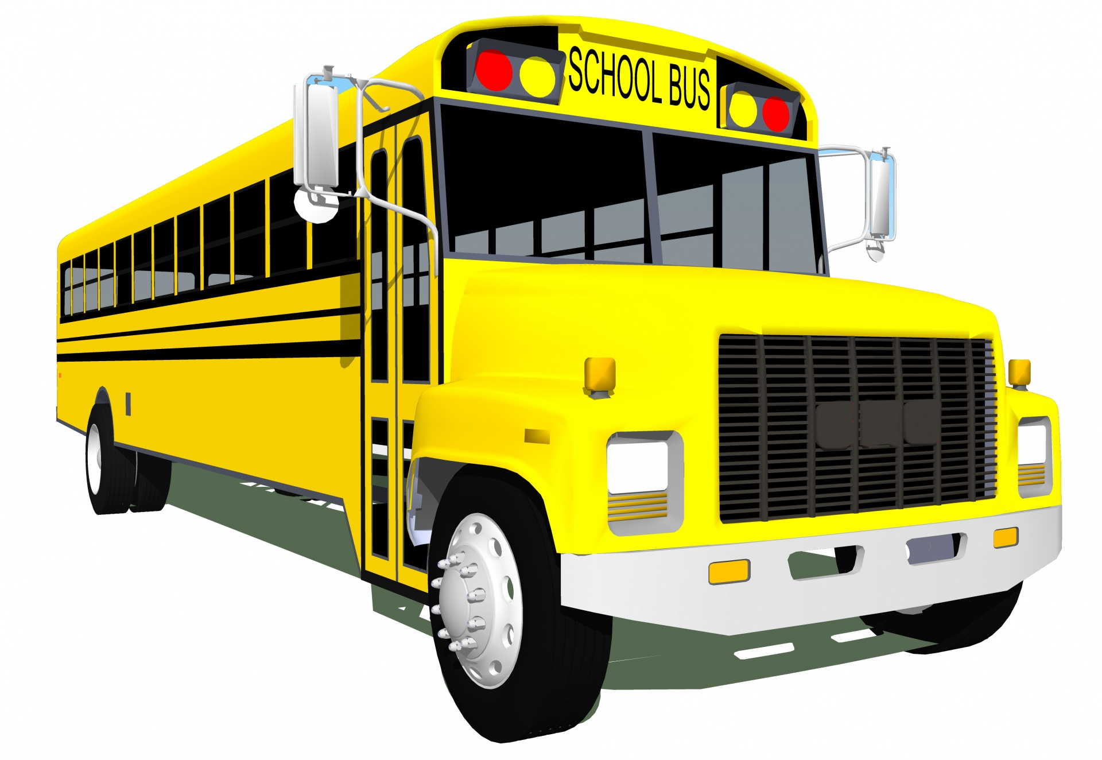
Please register for : this is the method used to pay for items such as student fees, class trips, tickets for drama productions and other items throughout the year.
For safety and efficiency reasons, ASD-S would like to reduce the amount of cash & checks coming into our school. Please join the thousands of parents who have already registered and are enjoying the convenience of paying ONLINE! It takes less than 5 minutes to register. Follow these step-by-step instructions to begin to receive email notifications regarding upcoming events involving your child(ren). NOTE: If you require assistance, select the SUPPORT option in the top right-hand corner of the screen or call our main office at 466-7303 and we would be happy to assist. You will only need to register your child once; their account will follow them through to graduation.
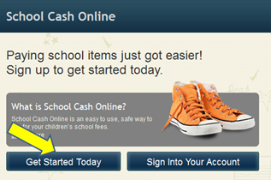
Step 1: Register
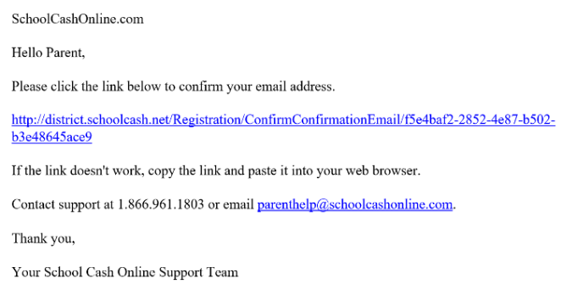
- If you have not registered, please go to the School Cash Online
home page https://district.schoolcashonline.com/
and select the “Get Started Today” option.

- Complete each of the three Registration Steps
*For Security Reasons your password, requires eight characters,
one uppercase letter, one lowercase letter and a number.
Step 2: Confirmation Email
A registration confirmation email will be forwarded to you. Click on the link provided inside the email to confirm your email and School Cash Online account. The confirmation link will open the School Cash Online site prompting you to sign into your account. Use your email address and password just created with your account.
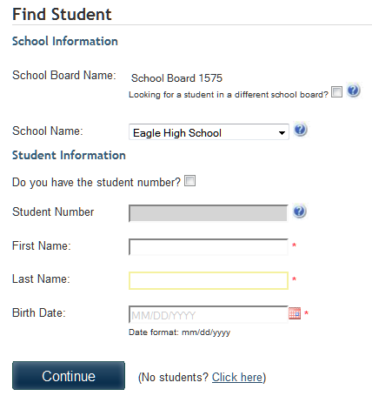
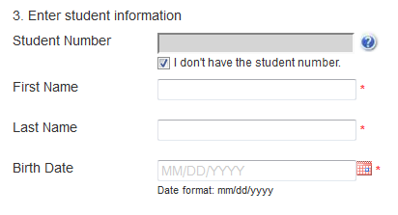
Step 3: Find Student
This step will connect your children to your account.
- Enter the School Board Name.
- Enter the School Name.
- Enter Your Child’s First Name, Last Name and Birth Date.
- Select Continue.
- On the next page confirm that you are related to the child, check in
the Agree box and select Continue.
- Your child has been added to your account.

Step 4: View Items or Add Another Student
If you have more children, select “Add Another Student” and repeat the steps above. Eight children can be added to one parent account. If you do not wish to add additional children, select “View Items for Students” option. A listing of available items for purchase will be displayed.

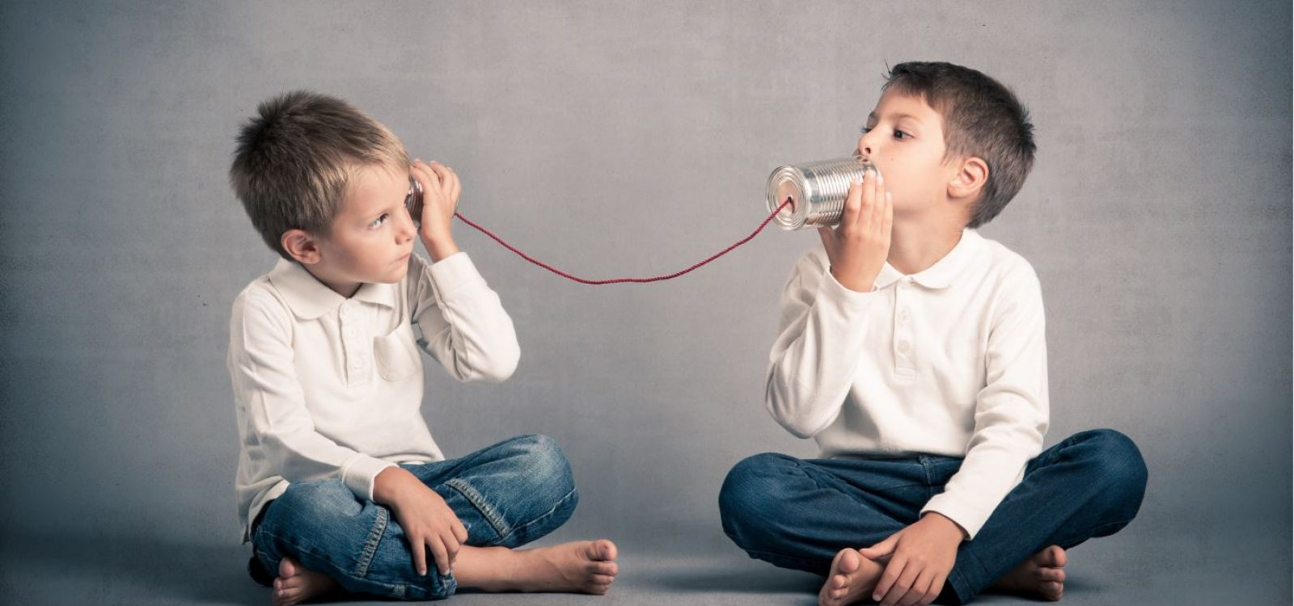
Communication Between Home and School

Communication between home and school is a very important factor contributing to student success at school. We encourage parents to communicate with teachers often. We provide a Student Agenda for each child at SSES and encourage you to communicate through the agenda, or you may also email. Email addresses can be found on our school website. If you wish to speak with a teacher directly, you may also call and leave a message at the office for the teacher to call you back.
If you have concerns, please contact the school. Talking with your child’s teacher would be the first avenue for expressing concerns. The administration of the school is also available to assist with further concerns.

Opportunities for Parent Involvement at St. Stephen Elementary School

SSES Home and School Association
Dear SSES Families,
The SSES Home and School Association would like to extend a warm WELCOME to our new families and a WELCOME BACK to those of you who are returning. We hope that your summer was filled with fun and relaxation and that you made a lot of wonderful memories with family and friends. It is hard to believe school is starting, but here we are, ready for a great year!
We are proud of what we have accomplished to date with the help of the school community. Parent involvement is a huge part of our success and there will be opportunities to volunteer through the year. We encourage you to get involved and play an active role in the educational and social experiences of our children!

Community School Coordinator


Dear SSES Families,
As Community School Coordinator I would like to extend a warm welcome to our new families and welcome back everyone who is returning. Hope you all had a great summer! Having your support and involvement is invaluable to us at SSES and the form in your parent information packet details all the fun ways you can get involved. I look forward to working together to make this a wonderful school year.
Catriona McLanaghan

Bullying

Having a clear definition of bullying will help students learn to identify it and respond to it appropriately.
Bullying is unwanted, aggressive behaviour that involves a real or perceived power imbalance. The behavior is repeated, or has the potential to be repeated, over time.
It is bullying when:
- It is one-sided.
- There is an imbalance of power (age, size, popularity).
- It is repeated.
- Someone is being hurt, physically or emotionally, on purpose.

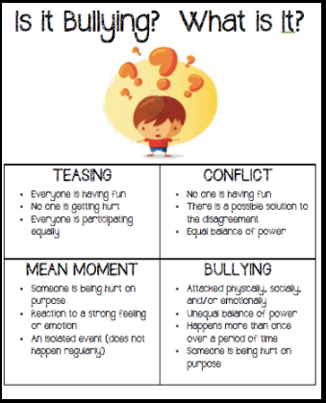

When it comes to bullying, we DO NOT tolerate it. We teach students to stand up to bullying and ask for adult help. We recognize that bullying-type behaviours require an adult to intervene. We are committed to making St. Stephen Elementary a safe and happy place for all students.
WITS is an anti-bullying program that is used at SSES to teach students strategies to protect themselves from forms of bullying. They know to:
Walk away.
Ignore it.
Tell someone.
Seek Help

Please reinforce these strategies with your child.
POSITIVE LEARNING ENVIRONMENT POLICY
Students throughout our school are taught what each of the “THREE BEES” means (classrooms, halls, cafeteria, buses, playground, washrooms, etc.) during the first few weeks of school and these are reinforced throughout the year. Being safe, respectful, and prepared will create a school where everyone feels they belong.

We believe that students, teachers, parents, and support staff are all important in the school community and need to feel connected, capable and that they all contribute to the learning environment.

We believe that all students have individual strengths and can grow academically, physically, socially, and emotionally.

We believe that all members of the school community – students, teachers, parents, and support staff should be safe, be respectful, and be prepared.
Believing this means that we need expectations for behaviour to help make St. Stephen Elementary a safe and positive learning environment. We expect all members of the school community to:
Be SAFE
Be RESPECTFUL
Be PREPARED

SSES is a PBIS School…
Using Positive Behaviour Interventions and Supports

Correcting Misbehaviour

Despite our intentions, problems can and do occur. It is our duty to maintain a Positive Learning and Working Environment, therefore we deal with these problems in a positive way, whenever possible. We will teach children to solve their problems and encourage students to be responsible for their behaviour. Parents/Guardians are an important part of making our school a safe learning environment and need to be aware of practices that keep our school safe.

When students make mistakes in these expectations, they are told what their mistake was and asked to correct it. When the behaviour continues, a consequence is put in place. Examples of these consequences could be:
- Time-out
- Office Referral
- Student/Teacher Conference
- Communication with Parent(s)
- Restitution (making it better)
- Loss of privileges (i.e. School groups / activities)
- Conference with the Teacher, Vice Principal or Principal
- Short-Term Intervention Plan
- Individual Behaviour Support Plan
- Alternate Educational Setting
- Home Suspension

Playground Misbehaviour

Teachers have created a leveled approach to student misbehavior, specifically for the playground during any given recess:

- 1st misbehavior: student will receive a verbal reminder of the behaviour expectation and have a 5 minute “think time” for time-out.
- 2nd misbehavior: student will receive a verbal reminder of the expected behaviour, and the student would spend the rest of the recess in a “think time” for time-out.
- 3rd misbehavior: student will be sent inside for detention.
- Continued assignments to a detention may result in an additional consequence, as listed above.

St. Stephen Elementary School Guidelines

KISS and DROP AREA | For the safety of students, please DO NOT PARK in the KISS and DROP- simply pull over, kiss, and drop.  Students walking to school use the patrolled crosswalk to cross King Street, with the assistance of our Crossing Guard.  Our parking lot is reserved for staff only in the morning between 7:45-8:25 am, as well as between 2:10 – 2:50 pm. Thank you for your assistance in keeping this area safe for students.
TELEPHONE | Students will always be able to use the office phone in the event of an emergency. Student use of personal cell phones at school is prohibited and cell phones should always be left at home.
MESSAGES FOR STUDENTS | Students should know their after-school plans before coming to school. In the event of an emergency or when plans must change, please call the school prior to 12:30 p.m. Our secretary organizes the messages for classrooms and these messages are sent down to teachers at 1:00 p.m. A note or call from the parents/guardians is required when a student has a different after-school plan than usual.
STUDENT MEDICATIONS | Please send a note if your child needs to be given medicine. Students who need medication regularly must complete a form (available from the Educational Support Teachers in the Resource Room). Provincial policy states that medication cannot be accessible to other children, therefore an adult must bring the medication to the school in a prescription bottle, identifying the child’s name and dosage. This medication will be kept in a locked cabinet in the Main Office and distributed as directed.
STUDENT ILLNESS | We do not have facilities at school to accommodate children who are ill. Whenever a child becomes ill, we will telephone home to request that someone pick him/her up. If parents are unable to pick up their child, an alternative arrangement must be made. Therefore, we require at least one emergency contact number in case no one is available at home.
PERSONAL BELONGINGS | Children’s clothes, boots, gloves, scarves, sneakers, lunch kits, book bags etc. should be marked with the child’s name. Clothing does get misplaced, and many children have identical or similar clothing. Every year many articles of clothing are left behind. Unclaimed items are collected occasionally and sent to charitable organizations or placed in our clothing closet for student use.  Lost, broken, or taken toys often cause a lot of distress for the children. Staff are not responsible for toys brought from home.  Video games, cell telephones, I-Pads, and other electronics are NOT the responsibility of the school and are to be left at home. Students are NOT permitted to use these electronics at school.  Bicycles, skateboards: Students are expected to walk their bicycles and skateboards when on school property. Bicycles must be locked and stored in the racks provided; other items are to be left in the coatrooms. The school does NOT assume responsibility for these if they are lost or stolen.
PROHIBITED ITEMS | Dangerous objects such as matches, knives, firecrackers, hardballs, and baseball bats are NOT to be brought to school. Inappropriate reading material and clothing displaying inappropriate logos (i.e. alcohol, tobacco, and drugs) are also prohibited.
STUDENT DRESS | Students are required to have indoor and outdoor shoes. School and fire regulations require students to always wear shoes.
FIRE DRILLS AND EMERGENCY EVACUATION | Fire drills and emergency drills are held regularly to ensure that the school can be prepared in an orderly and safe manner in case of an emergency. Wearing indoor shoes is mandatory since fire drills are unannounced and every person must leave the building when the fire alarm sounds.
ALLERGY ALERTS | We have several students and staff with nut and scent allergies. This is a life-threatening situation for some of these people. Our school is a Nut-Free and Scent Reduced Zone. Thank you for helping us to maintain a safe environment.
SCHOOL BUSES | It is critical for the students to comply with the bus rules and obey the Bus Driver’s requests. The bus driver must give most of his/her attention to driving the bus and any distractions may be the cause of an accident. Safe conveyance requires everyone’s help, “Be a part of the safety team”. AT ALL TIMES: Exercise care, caution, good manners, and consideration for others. IMPORTANT: Obey promptly the directions and instructions of the school bus driver.

